## Create the Base Roads

1. Select the **Road** tool from the Roads tab and create an east-west road of 2 lanes, then add a north-south road.

* 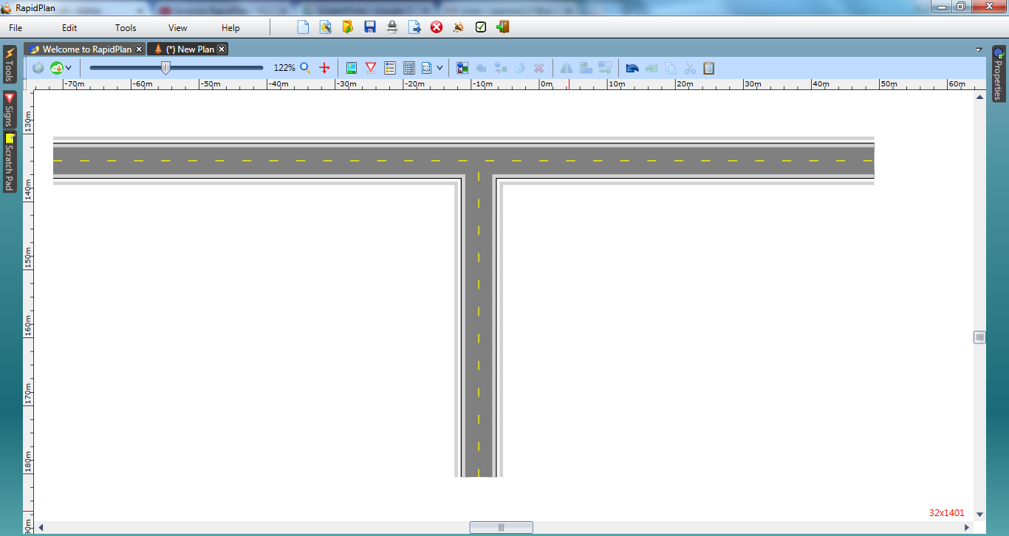
* Slip_Lanes_Intersection_step_1